Press Information

Isabellenhütte 1 / 2019

D-Dillenburg February 21, 2019

Innovative direct current meter for fast charging stations from Isabellenhütte and innogy
You can count on it (accurately)!
Electric car owners will benefit from IEM-DCC, an innovative direct current meter for fast charging stations, in the future when fast charging their cars. It allows for the charging process to be billed by the kilowatt hour. Isabellenhütte, technology leader in the field of shunt-based current and voltage measurement, and innogy, one of the leading German energy companies and specialist in electromobility infrastructure, developed the module together.
The development partnership has a legal background: Direct current measurement devices that comply with calibration law are required in fast charging stations for electric vehicles starting April 1, 2019. The problem: There have previously been no suitable models for this purpose. Customers can currently only be billed for their charging process down to the kilowatt hour at AC charging stations. In other words, they only pay for what they have actually used. This has currently not been possible at fast charging stations. Instead, drivers pay a uniform fixed price per charging process in the interim.
IEM-DCC in the type examination procedure
With the new IEM-DCC, which is currently in the type examination procedure of the Physikalisch-Technische Bundesanstalt [national metrology institute of Germany], Isabellenhütte and innogy have responded to the legal requirement and developed a non-exclusive direct current meter that complies with calibration law. It is based on a highly-accurate shunt-based current sensor from Isabellenhütte, which is integrated into the procedure for kilowatt hour-exact billing, which is patented by innogy (used at innogy AC charging stations since 2014). The concept of the IEM-DCC includes current and voltage measurement in an extremely compact and mechanically tamper-proof housing, which is smaller than a standard household meter. So even in the smallest of spaces, current measurements up to 500 A, voltage measurements up to 1,000 V and a four-wire measurement for the compensation of charging cable losses are possible. In order to make the communication from the meter to the back-end system tamper-proof too, Isabellenhütte relies on the extended EDL 40++ from innogy, which takes into account methods for signing the meter values and methods for time synchronization for the meter. The signing of the meter values in particular is crucial for publicly accessible charging points for a number of different customers in order to ensure safe communication that complies with calibration law.
DC meter generally available for the market
Dr. Jan Marien, head of Development at Isabellenhütte, explains the advantages for customers: “In addition to the technical realization, it was important to us in the cooperation, in agreement with innogy, that we do not develop an exclusive product due to the heterogeneous market and the multitude of market participants. Potential customers can also integrate the DC meter in their application without discrimination.” Tobias Wolff, Business Development manager of Isabellenhütte measurement systems, adds: “Since our concept was introduced at the BMWi workshop of the legal professional group in May 2018, the feedback from all known market participants has been tremendous.” Norbert Verweyen, CTO at innogy eMobility Solutions, emphasizes: "As a pioneer for kilowatt-hour precise billing at standard charging stations, we also want to offer this transparency for fast charging now. This is the fairest solution for the customers.”
Isabellenhütte is currently expecting the type examination certificate to be completed in the first half of 2019. Module-F tested and series produced IEM-DCC are to be expected in the third quarter.

3,792 stops

Image material:
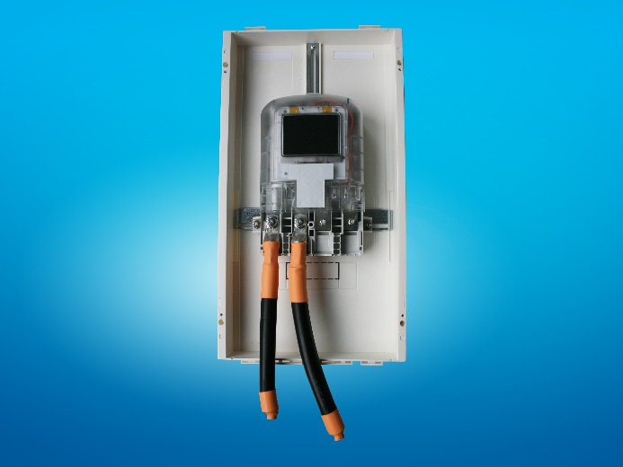

Image caption: The compact direct current meter IEM-DCC from Isabellenhütte and innogy is currently in the type examination procedure, which is expected to be completed in the first half of 2019.
Image: ©Isabellenhütte Heusler GmbH & Co. KG

About Isabellenhütte Heusler
The measurement systems from Isabellenhütte Heusler GmbH & Co. KG are leading technology in the field of shunt-based current measurement systems.

Isabellenhütte Heusler GmbH & Co. KG has been owned by the Heusler family since 1827. Around 900 employees work at the company headquarters and production location in Dillenburg (Hesse). www.isabellenhuette.de

Reprint free of charge
We ask that a voucher copy be sent to Wassenberg for reprint or editorial mention.
Thank you!

Company contact: Media:
Tobias Wolff Michaela Wassenberg
Business Development Manager Wassenberg Public Relations for
Measurement Systems Industrie und Technologie GmbH
Isabellenhütte Heusler GmbH & Co. KG
Eibacher Weg 3 - 5 Rollnerstr. 43
D-35683 Dillenburg D-90408 Nuremberg
Tel.: +49 2771 / 934-258 Tel.: +49 911 / 598 398-0
Fax: +49 2771 / 934-99282 Fax: +49 911 / 598 398-18
tobias.wolff@isabellenhuette.de m.wassenberg@wassenberg-pr.de

