Press Information

Isabellenhütte 5 / 2019

D-Dillenburg July 17, 2019

Isabellenhütte Heusler organized technical symposium on the occasion of the anniversary
Revolutionary Discovery 125 years ago: The Heusler Alloys
With his discovery in the year 1894, Dr. Fritz Heusler became the namesake of the “Heusler alloy.” A ferromagnetic alloy is created by combining three non-ferromagnetic elements. Today we know of more than 1,000 compounds and alloys. Isabellenhütte dedicated a technical symposium to the innovative entrepreneur and “his” alloys on the occasion of the 125th anniversary.

Dr. Felix Heusler, managing director in the 8th generation of Isabellenhütte, opened up the symposium and moderated the following lectures, which in honor of his great-grandfather and discoverer of the Heusler alloys, Dr. Fritz Heusler, paid tribute not only to the research work, but also the technological achievements, and showed the future projects of Isabellenhütte.

Ferromagnetic alloys – A sensational invention
To kick things off, the grandson of the namesake discoverer, Dr. Andreas Heusler, gave those present an overview of the history, from the somewhat random discovery of the Heusler alloys in 1894 to the patent application in 1901, to the publication of the collective findings at a meeting of the German Physical Society in 1903. At the time, Fritz Heusler made a significant contribution to the growing industrial sector of the electrical industry.
Throughout his life, the innovative entrepreneur Fritz Heusler also devoted himself to further research into ferromagnetic compounds. Isabellenhütte still takes this tradition of research into account today through its long-standing cooperation with the Department of Physics at the Philipps University of Marburg, as Prof. Dr. Kerstin Volz, Professor of Physics at the Philipps University, explained in her lecture. There has always been a close relationship and plenty of exchange between university in Marburg and Isabellenhütte, which supports the Department of Physics and research in the field of experimental materials research.

Far-reaching application possibilities
Prof. Dr. Claudia Felser, director and scientific member of the Max Planck Institute for Chemical Physics of Solids and Dr. Jan Marien, head of research and development at Isabellenhütte, dedicated their lectures to the practical application of Heusler and half-Heusler compounds.
With the wink of an eye, Claudia Felser first expressed her thanks to Fritz Heusler for her career: His groundbreaking discovery is one of her most important focuses of research. Heusler alloys today are one of the biggest material classes within ternary intermetallic compounds. Like with Lego blocks, explained Felser, almost any properties can be realized in Heusler compounds from many elements of the periodic table. New quantum properties based on the topology of the electronic structure can also be easily realized and are unique due to the flexibility of the composition of the Heusler compounds, the predictability of the symmetries and the electronic structure.

Energy generation of the future
In closing, Jan Marien made the connection to the daily development work of Isabellenhütte at present and in the future: In his lecture, he explained Isabellenhütte's strategy for the industrialization of thermoelectric materials for energy conversion. Tremendous amounts of energy are lost through waste heat between primary and useful energy. The thermoelectric waste heat power generation based on half-Heusler compounds counteracts this wasted energy. It can, for example, be used in cars, trucks and in the heavy industry. In the heavy and process industry in particular, thermoelectrics are becoming increasingly important, for example in the conversion of process heat generated during production processes, since the permanent heat radiation can be optimally used by the technology for energy recovery.
In addition to energy recovery, the charm of thermoelectrics, says Marien, is that no moving parts would be required, which minimizes the error rates and increases the life cycle.
Isabellenhütte is continuing to develop its thermoelectric materials constantly, therefore staying true to the company’s tradition of research.: “For a medium-sized company, it is rather unusual to spend so long on a topic that actually came about through research,” says Marien. Yet the transfer from research work to practical application is still an important part of the company’s policy. Isabellenhütte's technology for producing thermoelectric materials in marketable quantities is pioneering and is also supported by the federal government and the EU.

Far-sightedness and a spirit of innovation
The technical symposium, in which around 100 guests participated, was a huge success. The random discovery of the Heusler alloys offers plenty of room for research and pioneering ideas, even 125 years later.
5,129 characters

Image material:
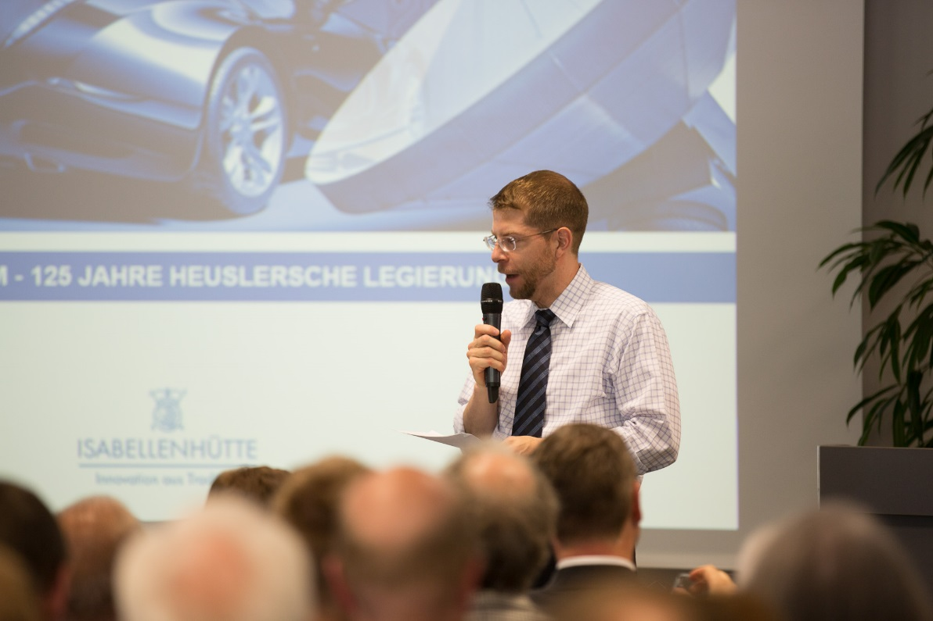

Image caption 1: Dr. Felix Heusler, managing director of Isabellenhütte, guided the audience through the lectures on the occasion of the anniversary. Image: ©Isabellenhütte Heusler GmbH & Co. KG

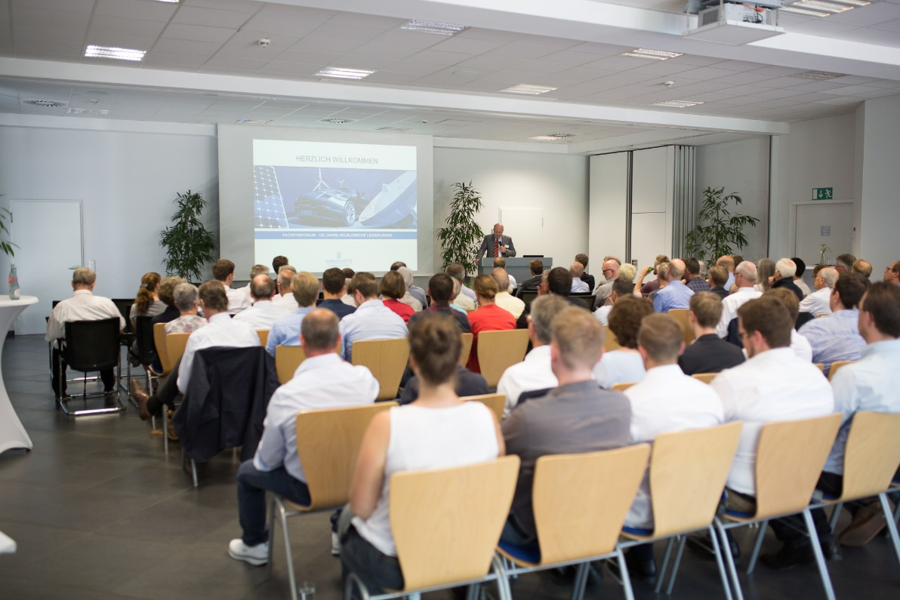
Image caption 2: Many interested people came to the technical symposium in honor of Dr. Fritz Heusler, whose discovery of the Heusler alloys is marked by the 125th anniversary this year. Image: ©Isabellenhütte Heusler GmbH & Co. KG

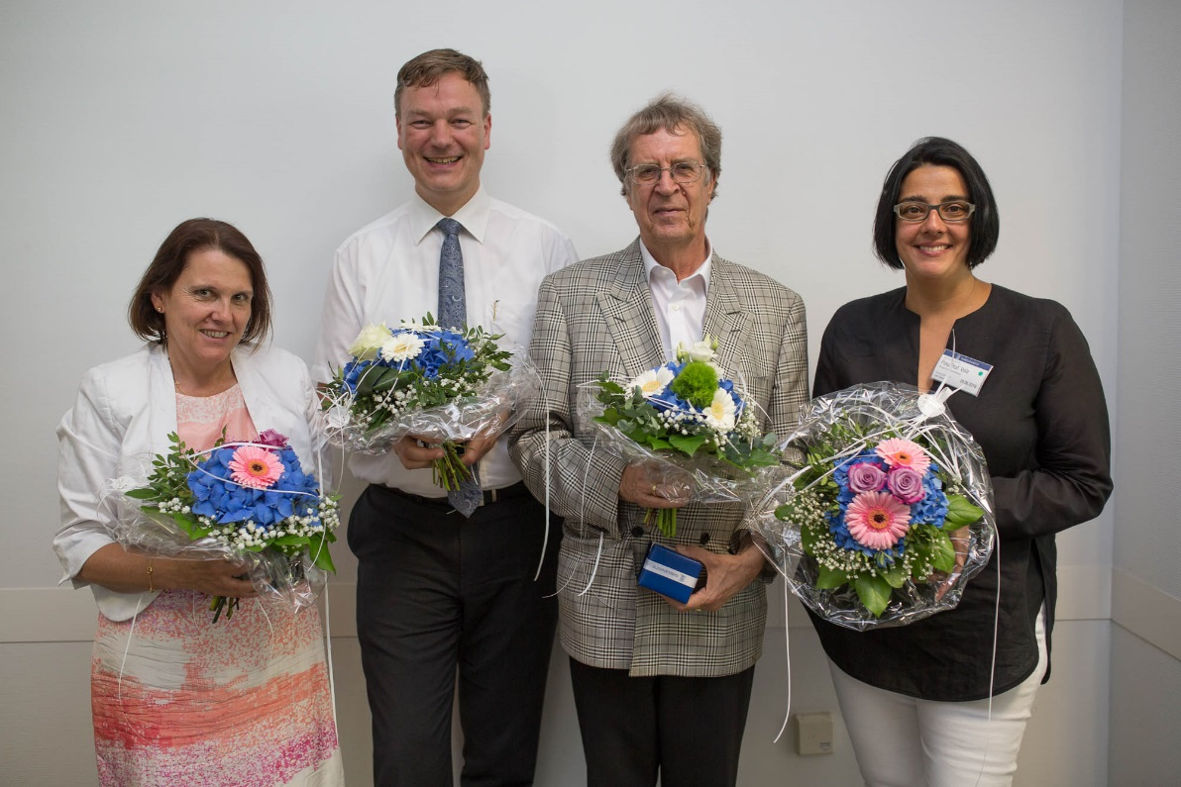
Image caption 3: The symposium speakers from left to right: Prof. Dr. Claudia Felser, Dr. Jan Marien, Dr. Andreas Heusler, Prof. Dr. Kerstin Volz. Image: ©Isabellenhütte Heusler GmbH & Co. KG

About Isabellenhütte Heusler
Isabellenhütte Heusler GmbH & Co. KG has been owned by the Heusler family since 1827. Today, they are one of the world's leading manufacturers of low-ohmic precision and power resistors. The company set standards with the invention of the ISA-WELD® procedure patented in 2014. Other corporate areas include the manufacture of precision alloys and measurement technology products. The measurement systems from Isabellenhütte are leading technology in the field of shunt-based current measurement systems. The company combines its precision measurement systems under the brand name ISAscale®. Around 950 employees work at the company headquarters and production location in Dillenburg (Hesse).
www.isabellenhuette.de

Reprint free of charge
We ask that a voucher copy be sent to Wassenberg for reprint or editorial mention.
Thank you!

Company contact: Media:
Rolf Viehmann Michaela Wassenberg
Head of Marketing Wassenberg Public Relations for
Isabellenhütte Heusler GmbH & Co. KG Industrie und Technologie GmbH
Eibacher Weg 3 - 5 Rollnerstr. 43
D-35683 Dillenburg D-90408 Nuremberg
Tel.: +49 2771 / 934-131 Tel.: +49 911 / 598 398-0
Fax: +49 2771 / 934-99131 Fax: +49 911 / 598 398-18
Rolf.Viehmann@isabellenhuette.de m.wassenberg@wassenberg-pr.de

