The BVF Precision Resistor:
Optimal interplay of material and geometry
Isabellenhütte Heusler GmbH and Co. KG has developed currently the smallest precision resistor available on the market in the BVF at 3.1 mm x 3.3 mm. It not only convinces with its small size, but also with its tremendous load capacity and the precision in use. Smaller electrically operated applications in particular benefit from the properties of the high-performance component.
The BVF precision resistor is extremely compact and therefore can also be used in particularly small installation spaces with a high power density. It is qualified according to AEC-Q200 and can be used in all automotive applications. The component can, however, also be used in equipment such as washing machines or air conditioners. The BVF shunt is built into modules that control brushless DC motors (BLDC motors). These BLDC motors in turn drive the motor that, for example, drives the washing machine drum or controls the air conditioner’s cooling output.

Maximum Performance, Minimal Size
Isabellenhütte is once again taking on a pioneering role with the development of the BVF. The precision resistor is currently globally unique with its small overall size of just 3.3 mm x 3.1 mm. The temperature coefficient of the BVF is just under 70 ppm/K. The thermal resistance Rthi (Internal Heat Resistance) is also extremely low at 10 K/W. These properties result in the high load capacity of the BVF of 3 watts at up to 145°C at the contact point (T_{K}). Even after 2,000 hours of rated power, the precision resistor still delivers accurate measurement results with only slight deviations of less than 1.0% (T_{K} =145°C). The BVF can be used in a temperature range from -65°C to +175°C.
The copper contacts of the BVF and the centrally located resistance material NOVENTIN® can be clearly and precisely connected via the method for the production of precision resistors from electron beam-welded composite material, so-called ISA-WELD® components, which was developed by Isabellenhütte and patented by 2014. After the electron beam welding, this results in a so-called tri-band, from which the components are punched out.
With comparable components, Isabellenhütte has previously mainly relied on resistance alloys such as ZERANIN®, MANGANIN® and ISAOHM®. However, the specific requirements for the overall size of the BVF could not be achieved with these alloys. By using the new type of alloy developed by Isabellenhütte and registered as a brand name as NOVENTIN® as a resistance material, tremendous performance is provided despite the small dimensions. The specific resistance of NOVENTIN® at 90 µOhm x cm is around twice as high as the resistance of MANGANIN® (43 µOhm x cm). The resistance alloy also has a particularly low temperature coefficient in the range of +20°C and +50°C. The R(T) curve has a parabolic shape. NOVENTIN® has a high long-term stability, extremely low thermoelectric power against copper and a good processability.

Material and Geometry Complement Each Other
The material properties also allow for freedom in the geometric design of the BVF precision resistor. The combination of a small component geometry, the required resistance values of 1 mOhm or 1.5 mOhm and the installation capability of the BVF use requires a height difference between the outer copper contacts and the central resistance material. The gradation prevents the resistance material from getting wet with solder, as otherwise the measuring accuracy of the component would be restricted. This is a challenge with this small overall size. The solder joint must be of a high quality and be well made so that the heat generated from the high performance of the BVF can flow out into the printed circuit board accordingly. The small overall size not only places high requirements on soldering when integrated into applications, but also places high requirements on the arrangement of the measuring line below the component and on the position of the sensor taps.

From Customer Inquiry to Series Production
The BVF precision resistor was originally a customer development by Isabellenhütte. A solution was needed that could deliver optimal results despite the small installation space. In the course of the development process, the company decided to produce the BVF precision resistor in series production to include it in the product range as a standard component.
Isabellenhütte has long been established as a supplier of resistors, especially in the automotive industry. However, the use of the BVF is far from restricted to the automotive sector. It is actually extremely versatile. For example, the company supplies the BVF for use in Asia in the electric scooters, which are in very high demand there. The BVF is also integrated in air conditioners or washing machines. In general, the precision resistor can be used in all applications that are driven with BLDC motors. The shunt is built into power modules that control these motors. The energy efficiency of devices is becoming increasingly important. An air conditioning system, for example, can be controlled more precisely and ensure appropriate cooling, even with less power consumption. The required torque of a washing machine can be appropriately dynamically adapted to the load during the slow washing process.
Precision resistors such as the BVF deliver the measurement results.

The BVF precision resistor is currently the smallest of its kind on the international market at just 3.1 mm x 3.3 mm. Image: © Isabellenhütte Heusler GmbH & Co. KG

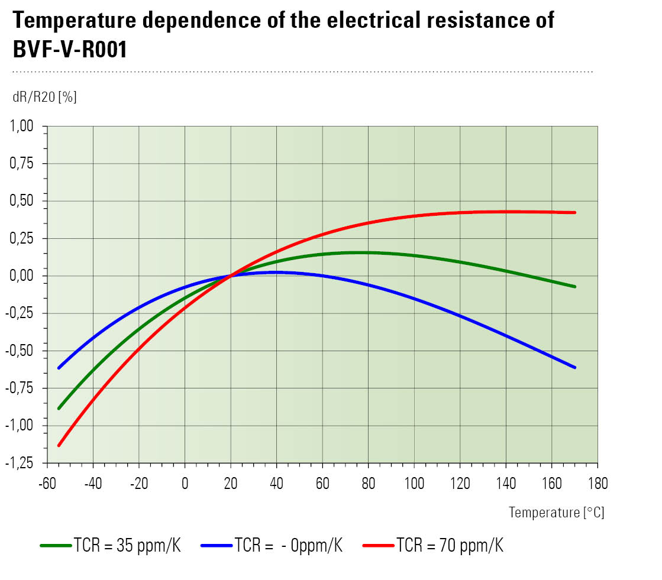
The temperature coefficient of the BVF is just under 70 ppm/K and is therefore extremely low compared to similar components. Image: © Isabellenhütte Heusler GmbH & Co. KG

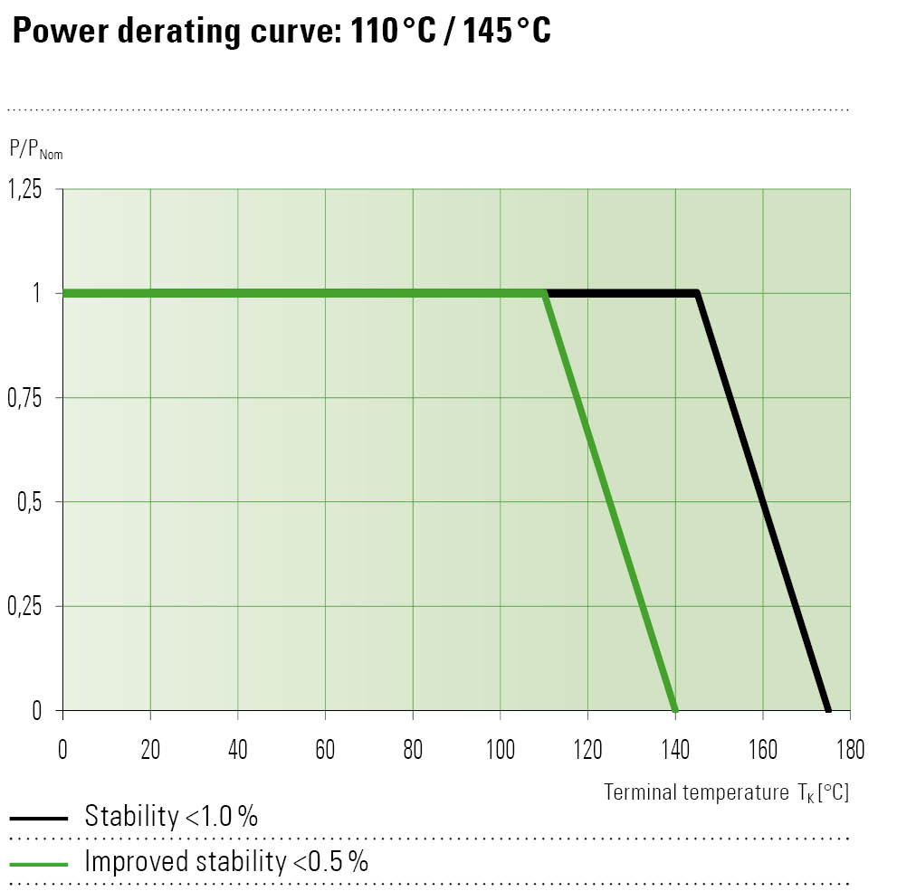
The BVF provides the most accurate measurement results, even when used in a high-temperature environment.
Image: © Isabellenhütte Heusler GmbH & Co. KG

