Press Information

Isabellenhütte 6 / 2019

D-Dillenburg December 13, 2019

Isabellenhütte receives type examination certification from PTB Braunschweig
Roll-out for the first DC meters compliant with calibration law for charging infrastructure
As a specialist for shunt measurement technology, Isabellenhütte presents the first shunt-based, calibration law-compliant DC energy reference meter IEM-DCC-500 for charging infrastructure following the successful completion of the type examination. The DC meters are now available for purchase by manufacturers of charging stations and can be integrated into the designs of their applications.
The basis of the type examination certification was the successfully conducted metrological measurement series (accuracy class B), the operation of the software in compliance with calibration law, the corresponding documentation for the customers and institutes, as well as the positive completion of the EMC and environmental impact studies. Andreas Prüfling, Director of the Business Unit Measurement at Isabellenhütte: “We thank PTB Braunschweig for this good collaboration, which has ultimately led us to achieving a solution for the market that complies with calibration law. Simultaneously, we have expanded series production so that the DC meter is now directly available to recharging station manufacturers.” The design features integrated current and voltage measurement (500 A and 1,000 V) as well as the calibration law-relevant periphery in a compact housing that is secured against manipulation.
Strategic partnerships
The good news didn’t only bring relief to the development partner positive Innogy, which is itself still in the process of completing the type examination for its own recharging station solution with integrated IEM-DCC-500, but also for Isabellenhütte’s other strategic cooperation partners. Tobias Wolff, Business Development Manager for Smart Grid at Isabellenhütte had this to say: “We are currently helping five recharging station manufacturers to integrate our DC meter into their hardware structure. We would like to use our experience to support more companies with design integration in order to make the certification process for recharging station concepts easier.” The topic of “calibration-compliant DC energy measurement” has further potential for Isabellenhütte. Aspects such as adaptation to various power classes, increases in cost coefficients, and perspectives beyond the boundaries and market requirements of the EU promise an expanding field of business.
2,466 characters

Image material:

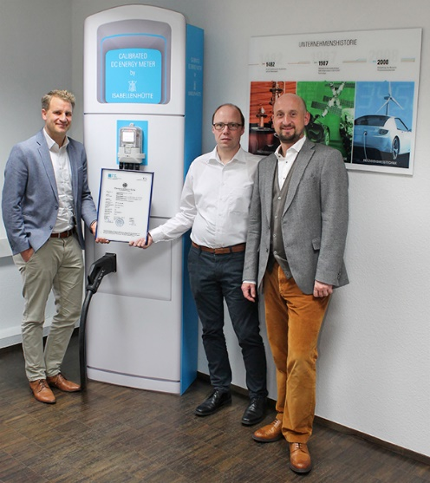
Image caption 1: The type examination certification for the first DC meters compliant with calibration law is here (from left to right: Tobias Wolff, Business Development Manager Smart Grids, Andreas Lepper, Project Manager R & D Business Unit Measurement, and Andreas Prüfling, Director Business Unit Measurement). This signals the start of the roll-out.
Image: ©Isabellenhütte Heusler GmbH & Co. KG

About Isabellenhütte Heusler
Isabellenhütte Heusler GmbH & Co. KG is a leader in the field of shunt-based current measurement technology. Its precision measurement systems are marketed under the ISAscale® brand.
Isabellenhütte Heusler GmbH & Co. KG has been owned by the Heusler family since 1827. The company employs some 950 people at its headquarters and production location in Dillenburg (Hesse, Germany).

Company Contact: Media:
Rolf Viehmann Michaela Wassenberg
Leiter Marketing Wassenberg Public Relations für
Isabellenhütte Heusler GmbH & Co. KG Industrie und Technologie GmbH
Eibacher Weg 3 - 5 Rollnerstr. 43
D-35683 Dillenburg D-90408 Nürnberg
Tel.: +49 2771 / 934-131 Tel.: +49 911 / 598 398-0
Fax: +49 2771 / 934-99131 Fax: +49 911 / 598 398-18
rolf.viehmann@isabellenhuette.de m.wassenberg@wassenberg-pr.de

