Press release

Isabellenhütte 4 / 2017

Dillenburg, Germany
24 August 2017

Electromobility – Fraunhofer IISB and Isabellenhütte
IVT-S measures current in the Fraunhofer development platform foxBMS

The Fraunhofer Institute for Integrated Systems and Device Technology (IISB), Erlangen, is using Isabellenhütte’s shunt-based management system IVT-S for precision current measurement in battery management systems in its foxBMS development platform.
The Isabellenhütte IVT series offers precise, temperature-compensated current and voltage measurement in a single component. Isabellenhütte's IVT systems are mainly used in the rapidly growing market for lithium-ion traction batteries and can be found in electric cars, electric trucks, electric buses and electric aircraft as well as in materials handling.

Fraunhofer IISB foxBMS – a gateway for researchers and developers
foxBMS is a research and development platform for battery management systems, which was developed by the Fraunhofer IISB based in Erlangen. foxBMS is an open-source platform, meaning that any companies or research institutes are free to use it to develop or test their own products – such as electric vehicles or applications with similar requirements.

Integrated system for precision measurements: IVT-S in the foxBMS
Fraunhofer IISB uses Isabellenhütte's IVT-S measurement system to achieve high-precision current measurements in the foxBMS platform. “We opted for the IVT-S from Isabellenhütte because this current sensor offers precision current measurement in combination with coulomb counting to determine state of charge in automotive battery systems up to 1,000 V,” explains Dr.-Ing. Vincent Lorentz, Group Manager Battery Systems at Fraunhofer IISB.

The IVT-S from Isabellenhütte has a galvanically isolated CAN interface. The integrated, three-channel HV sensor measures the voltage of the battery and monitors high-voltage protection and fuses.

The IVT-S is often used in the power distribution unit, the battery junction box or the HV box. This area is isolated from the battery cells and the BMS and often contains the circuit breaker on the plus/minus side of the battery and the pre-charging circuit required for traction batteries. The sensor is placed in the battery's minus pole, as the current measurement always takes place in relation to the voltage of the shunt ground. This enables the overall battery voltage to be monitored. In addition, voltage measurement can also be used to monitor the pre-charging circuit or the circuit breaker.

The IVT-S's integrated CAN bus interface ensures a reliable flow of data between the IVT-S and foxBMS. Due to the high level of precision and resolution in the mA range, the IVT-S also detects standby current and enables the foxBMS to record extremely precise information on the SoC (state of charge), SoH (state of health) and SoF (state of function) parameters of the overall battery system.
Besides raw data for current and voltage measurement, the BMS can also provide temperature, output and energy values through the CAN bus interface. The IVT-S also offers an ampere-hour meter for charging and discharging currents. The robust high-voltage box protects the IVT-S system from environmental stresses.

State-of-the-art measurement system
With 1 kV of permanent isolation voltage and a maximum peak voltage of 6 kV, Isabellenhütte is responding to the higher voltage ranges only made possible by lithium-ion technology. The IVT-S is a standard product now available in a dynamic market, offering state-of-the-art technology and meeting countless application-specific requirements.

3,019 characters / 3,527 keystrokes

About Isabellenhütte Heusler
Isabellenhütte Heusler GmbH & Co. KG is a leader in the field of shunt-based current measurement technology. Its precision measurement systems are marketed under the ISAscale® brand.
Isabellenhütte is a leading force in the area of precision alloys and also plays a pioneering role in low-ohm precision and high-performance resistors.
The company has been owned by the Heusler family since 1827. It currently employs some 850 people at the company headquarters in Dillenburg (Hesse).
www.isabellenhuette.de
Images:

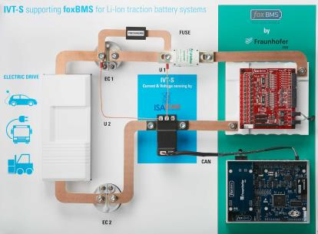

Image 1: Isabellenhütte’s high-precision current measurement system, IVT-S, measures current in the foxBMS development platform at the Fraunhofer IISB, Erlangen.
Photo: © Isabellenhütte Heusler GmbH & Co. KG

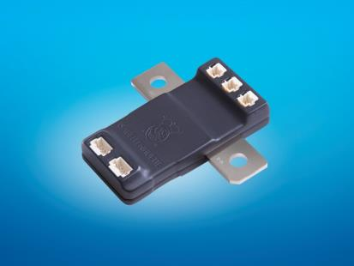

Image 2: The IVT-S current measurement system from isabellenhütte has an integrated CAN bus interface, which ensures the smooth transfer of data between the measurement device and the application.
Photo: © Isabellenhütte Heusler GmbH & Co. KG

May be reprinted free of charge
Please send examples of reprints and editorial use to Wassenberg.
Thank you!

Company contact: Media:
Tobias Wolff Michaela Wassenberg
Precision Measurement (VT-MT) Wassenberg Public Relations
Area Sales Manager – DACH für Industrie und Technologie GmbH
Isabellenhütte Heusler GmbH & Co. KG Rollnerstraße 43
Eibacher Weg 3-5 D-90408 Nürnberg / Germany
D-35683 Dillenburg / Germany
Phone: +49 (0)2771 / 934-258 Phone: +49 (0)911 / 598 398 - 0
Mobile: +49 (0)170 / 7846265 Fax: +49 (0)911 / 598 398 - 18
Fax: +49 (0)2771 / 934-99258 m.wassenberg@wassenberg-pr.de
Tobias.Wolff@isabellenhuette.de www.wassenberg-pr.de
www.isabellenhuette.de
Jens Hartmann
Sales Director ISAscale
Isabellenhütte Heusler GmbH & Co. KG
Eibacher Weg 3 – 5
D-35683 Dillenburg / Germany
Phone: +49 (0)2771 / 934-250
Mobile: + 49 (0)170 / 779 0830
Fax: +49 2771 934-99258
Jens.Hartmann@isabellenhuette.de
www.isabellenhuette.de

