Press Information

Isabellenhütte 3 / 2018

D-Dillenburg 18 June 2018

New technology for CO₂ reduction
Half-Heusler waste heat conversion reduces CO₂ emissions of cars
In the energy debate about CO₂ reduction, Hesse’s oldest industrial company, Isabellenhütte, is now making a promising contribution that is about ready to launch on the market. The basic idea: generate electricity from unused waste heat. The technology uses a new class of thermoelectric material to achieve this. The aim of the technology is, for example, to save up to 4% CO₂ emissions when used in a car.

Together with several partner companies, Isabellenhütte has now succeeded in getting the so-called half-Heusler material, a class of thermoelectric material newly discovered by scientists 15 years ago, ready for marketability. The aim of this cooperation was and is to depict the entire added value - from development to production to the specific application. The current EU project INTEGRAL* is now focusing on the construction of three pilot productions. The goal of the established pilot lines is to produce thermoelectric material in large quantities. Already at the project halfway point in May 2018, Isabellenhütte was able to successfully demonstrate the complete production process for material batches of 10 kg with its production line.
Annual production volume of 25 tons of half-Heusler material possible
A 150 m² production hall was built for this purpose at the company headquarters in Dillenburg, Hesse. Overall, a total of six scientists and technician are currently working on this topic at Isabellenhütte. 10 kg of thermoelectric half-Heusler material are currently being melted there per production run and processed further into functional components. This quantity is to be increased to 50 kg by the end of the project in December 2019. Theoretically, a production volume of up to 500 kg per production run is possible with the system. This corresponds to an annual production of 25 tons.

Thermoelectric waste heat conversion is nearly ready for market
Thermoelectric waste heat conversion based on half-Heuslers is almost ready for market. The technology was and is already tested and tried in the exhaust gas systems of cars and trucks under realistic everyday conditions. With 60 to 70 grams of half-Heusler material, a vehicle with a thermoelectric generator (TEG) installed achieves an efficiency of up to 5% from the waste heat. This energy is converted into electricity and fed into the on-board electrical system. The effect: The fuel consumption is reduced and the CO₂ emissions are reduced per vehicle by up to 4%.
Relevant for environmental policy and competitive
The relevance of this technology is obvious. Automotive manufacturers will face strict environmental requirements in the future. This is why every gram of CO₂ saved matters. The half-Heusler waste heat conversion is also competitive from an economic point of view. The production process realized as part of the EU project generally makes it possible to achieve the market-demanded cost target of EUR 0.50/watt under mass production conditions. A half-Heusler-based thermoelectric generator that, for example, generates 400 watts of electrical energy, would cost about EUR 200.
A good mix of properties allows for use in high-temperature applications
Due to their good material properties, half-Heusler materials are suitable for high-temperature applications, such as combustion engines. They generate exhaust gas temperatures between 400 and 600°C. With the aim of reducing emissions, a half-Heusler-based recuperation is therefore recommended for continuously operating high-temperature applications in the energy, metal or chemical industries. It is also attractive for the end user, because it can also be used in fireplaces or heating systems.
This commitment from Isabellenhütte is no coincidence. The predecessor of the half-Heusler material class, the so-called Heusler alloys, were discovered over 100 years ago by Dr. Fritz Heusler, the great grandfather of today’s managing director of Isabellenhütte, Dr. Felix Heusler.
4,023 Keystrokes

*The project INTEGRAL is supported by EU Horizon 2020 research and innovation programs under the funding number (EU Grant Agreement Number) 720878.

Publication notice about INTEGRAL:
When mentioning the project name INTEGRAL, legal reasons make it necessary to publish the EU logo “HORIZON 2020” and the aforementioned logo text in full.

About Isabellenhütte Heusler
Isabellenhütte arose from a copper smelter, which was first documented in 1482 and was renamed as “Isabelle Kupferhütte” in 1728. Since 1827, Hesse’s oldest company has been run as a family-owned and operated business, now in its eighth generation.
In 1901, Dr. Fritz Heusler discovered the Heusler alloys. They consist of non-magnetic individual components. However, when the elements are combined in Heusler compounds, they have strong ferromagnetic properties.
Heusler compounds are the historic predecessors of the material class discovered by scientists about 15 years ago, the so-called half-Heusler compounds. They are characterized by a flexible grid structure that can be filled with different metals. The effect: This results in countless material combinations with different physical properties. The half-Heusler production of thermoelectric generators also benefits from this, which Isabellenhütte uses for the waste heat conversion in high-temperature applications, such as combustion engines.
With around 950 employees, the company operates internationally in the three business divisions of precision measurement technology, precision and power resistors and precision alloys. It is one of the most important international manufacturers of electrical resistance materials and thermoelectric materials for temperature measurement as well as of passive components.
www.isabellenhuette.de

Image material:
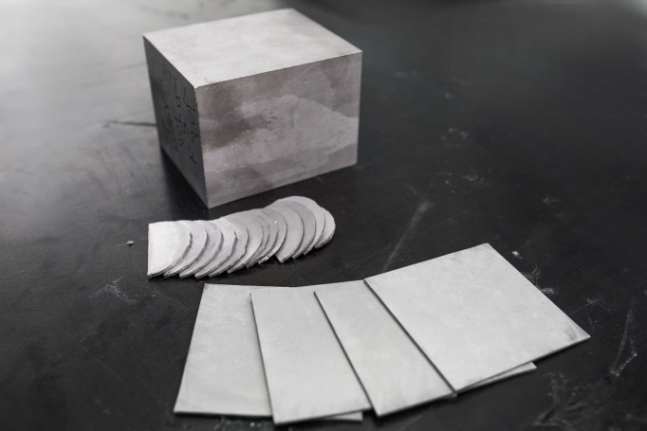
Image 1: Brick and wafer of half-Heusler material. Image: © Isabellenhütte Heusler GmbH & Co. KG

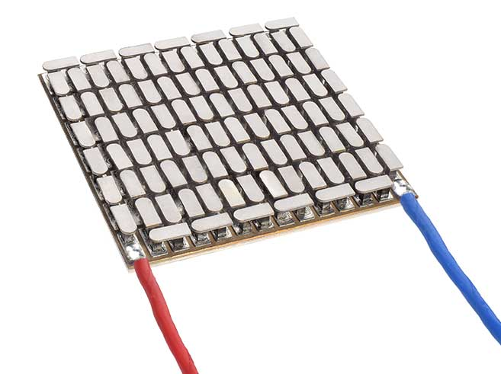
Image 2: About 60 to 70 grams of half-Heusler material are installed in a thermoelectric generator (in the image) to convert waste heat into electricity.
Image: © Isabellenhütte Heusler GmbH & Co. KG

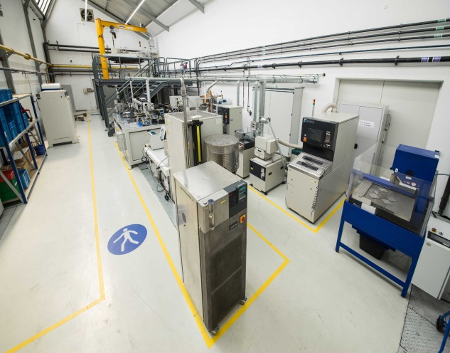
Image 3: Overall view of the pilot production line of half-Heusler material.
Image: © Isabellenhütte Heusler GmbH & Co. KG

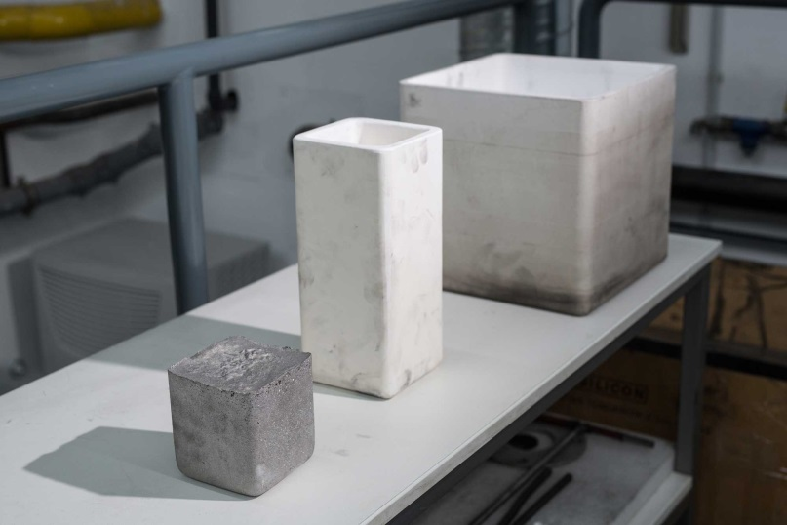
Image 4: 2 weight classes of melting pots: 10 kg, 25 kg
Image: © Isabellenhütte Heusler GmbH & Co. KG

Reprint free of charge
We ask that a voucher copy be sent to Wassenberg for reprint or editorial mention.
Thank you!

Company contact: Media:
Dr. Jan Marien Michaela Wassenberg
Head of Development / Wassenberg Public Relations for
Executive Vice President R&D Industry and Technology GmbH
Isabellenhütte Heusler GmbH & Co. KG Rollnerstr. 43
Eibacher Weg 3 - 5 D-90408 Nuremberg
35683 Dillenburg, Germany Tel.: +49 911 / 598 398-0
Tel.: +49 2771 / 934-254 Fax: +49 911 / 598 398-18
Fax: +49 2771 / 934-99254 m.wassenberg@wassenberg-pr.de
Jan.Marien@isabellenhuette.de

